THE COUNTY & DISTRICT CLERKS’

ASSOCIATION OF TEXAS

VICE PRESIDENT | 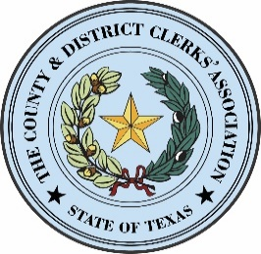 | SECRETARY
 |  | JOHN WARREN  DALLAS COUNTY CLERK  1201 ELM ST., STE. 2100  DALLAS, TEXAS 75202  PHONE: 214-653-7096  FAX: 214-653-7176  john.warren@dallascounty.org
  JULIE SMITH
  POTTER COUNTY CLERK
  P.O. BOX 9638
  AMARILLO, TEXAS 79105-9638
  PHONE: 806-379-2288
  FAX: 806-379-2296
  juliesmith@co.potter.tx.us

TREASURER | PRESIDENT | IMMEDIATE PAST PRESIDENT
velva.price@traviscountytx.gov
  VELVA PRICE
  TRAVIS COUNTY DISTRICT CLERK
  P.O. BOX 6790003
  AUSTIN, TX 78767
  PHONE: (512) 854-9737
  FAX: (512) 854-4744
  PATTI HENRY
  CHAMBERS COUNTY DISTRICT CLERK
  P.O. BOX NN
  ANAHUAC, TEXAS 77514
  PHONE: 409-267-2436
  FAX: 409-267-8209
  phenry@chamberstx.gov
  STACEY KEMP
  COLLIN COUNTY CLERK
  2300 BLOOMDALE, SUITE 2016
  MCKINNEY, TEXAS 75071
  PHONE: 972-548-4185
  FAX: 972-547-5731
  skemp@collincountytx.gov
SPECIAL MEETING OF THE BOARD OF DIRECTORS
MEETING AGENDA
SEPTEMBER 12, 2022
TEXAS A&M HOTEL & CONFERENCE CENTER, COLLEGE STATION
_____________________________________________________________________________________

NOTICE IS HEREBY GIVEN THAT A MEETING OF THE COUNTY AND DISTRICT CLERKS’ ASSOCIATION BOARD OF DIRECTORS WILL BE HELD AT 11:00AM ON MONDAY, SEPTEMBER 12, 2022 AT WHICH TIME THE FOLLOWING ITEMS WILL BE DISCUSSED AND/OR ACTED UPON:
Call to Order – 1:30 p.m. - President Patti L. Henry
Roll call – Secretary John Warren
Invocation – Vice President Julie Smith
Pledges to American and Texas Flags – Treasurer Velva Price

Deliberate and Take Action on the Following:

- ACTION ITEM: Consider approving cost to update the cdcat website to a new platform to improve performance and expand its capabilities.

- Adjourn

Dated this the 12th day of September, 2022.
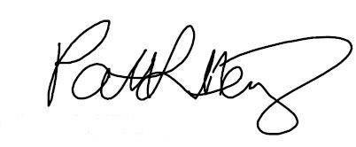

Patti L. Henry, CDCAT President
Chambers County District Clerk

